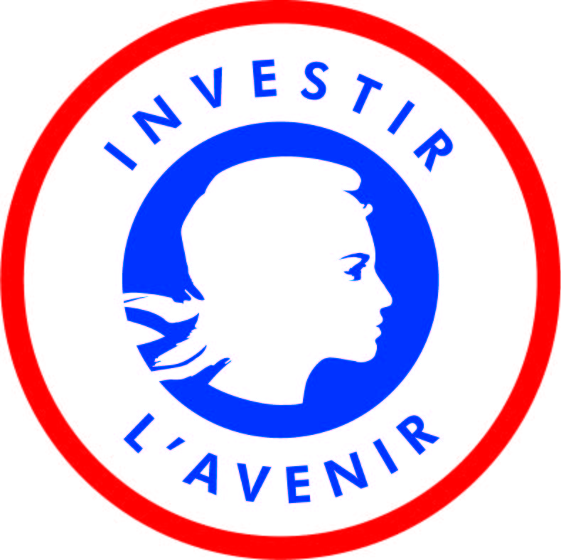

Co-Supervised Doctorates 2020
I-SITE ULNE – University of Kent

Name of the PhD candidate: _______________________

Thesis project proposal
to be completed in English

Deadline: April 29, 2020 (2:00 PM, Paris Time)

Please send your application by e-mail to the following address: international@isite-ulne.fr
(Please copy the promotors/supervisors and co-promotor/supervisor(s) on the message.)

Checklist of mandatory documents
(no hard copies are required)
Please send your documents using the following name template:
“[First name]_[name]_[Document name]_PhDKent_2020”.

☐ 2-page CV for each promotor/supervisor and co-promotor/supervisor
☐ Application form duly completed

For the applicant:
☐ Curriculum Vitae
☐ Cover letter
☐ Copy of passport for students who are not French citizens
☐ Grades obtained during your last 3 years of graduate studies and a description of the degree programme and courses taken for studies completed outside of France. (Official academic transcripts must be provided for each semester of each year.)
☐ Copy of post-secondary diplomas (with translation for degrees that were not obtained from an English- or French-speaking country; at this stage these copies do not have to be legalized)
☐ A letter of support from the potential I-SITE ULNE promotor

I-SITE ULNE Help desk:
stephane.thys@isite-ulne.fr
alexis.boulet@isite-ulne.fr

- PROJECT INFORMATION
Project title (English)
Project acronym
Keywords (between 3 and 6)

  - Identification of the PhD candidate
First name: Last name:
Gender:
Nationality:
Date of birth:
University of origin:
Master’s degree obtained:
Postal address:

Personal telephone:
Work telephone:
Email address:
Signature:

  - Identification of the I-SITE ULNE promotor
First name:
Last name:
Institution:
Faculty/Department:
Research unit:
Do you have an HDR?: ☐ No ☐ Yes, since:
Address:

Tel:
Email address:
Signature¹:

  - Identification of the I-SITE ULNE co-promotor (if applicable)
First name: Last name:
Institution²:
Faculty/Department:
Research unit:
Do you have an HDR?: ☐ No ☐ Yes, since:
Address:

Tel:
Email address:
Signature³:

  - Identification of the University of Kent supervisor
First name: Last name:
Faculty:
School:
Address:

Tel:
Email address:
Signature:

  - Identification of the University of Kent co-supervisor (if applicable)
First name: Last name:
Faculty:
School:
Address:

Tel:
Email address:
Signature³:

- Abstract of the thesis project (250 words maximum)
[To be completed]

PRESENTATION OF THE PROJECT (max. 3 pages excluding the bibliography)
- The doctoral project and methodology, including concrete calendar and selected bibliography
- Added-value of the participation of the (co-)promotors/supervisors in the project
- Strategy for dissemination and exploitation of the research
[To be completed]

Specific Questions
Explain briefly what scientific activities you plan to carry out during your stay at the University of Kent (max. 300 words)
[To be completed]

Explain how the involvement of the (co-)supervisors from the University of Kent in the framework of a co-supervised PhD is an added value to the PhD research. (max. 300 words)
[To be completed]

CVs of all promotors/supervisors and co-promotors/supervisors (Send each CV as a separate PDF file)
Please send the CV (maximum 2 pages each) of each promotor/supervisor and co-promotor/supervisor listed under point 2. The CV should include the 10 most important projects and/or publications of the past 5 years.

Mandatory documents for the applicant (Send each as a separate PDF file)
- Curriculum Vitae (CV)
- Cover letter (one-page minimum)
- Copy of passport for students who are not French citizens
- Grades obtained during your last 3 years of graduate studies and a description of the degree programme and courses taken for studies completed outside of France. (Official academic transcripts must be provided for each semester of each year.)
- Copy of post-secondary diplomas (with translation for degrees that were not obtained from an English- or French-speaking country; at this stage these copies do not have to be legalized)
- A letter of support from the potential I-SITE ULNE promotor

Scanned signatures are acceptable
Université de Lille, Centrale Lille Institut, ENSAIT, IMT Lille-Douai, Sciences Po Lille, ESJ, ENSAPL, ENSAM- Campus de Lille, CNRS, INSERM, INRIA, CHRU de Lille and Institut Pasteur de Lille
1 Scanned signatures are acceptable 2 Université de Lille, Centrale Lille Institut, ENSAIT, IMT Lille-Douai, Sciences Po Lille, ESJ, ENSAPL, ENSAM- Campus de Lille, CNRS, INSERM, INRIA, CHRU de Lille and Institut Pasteur de Lille

